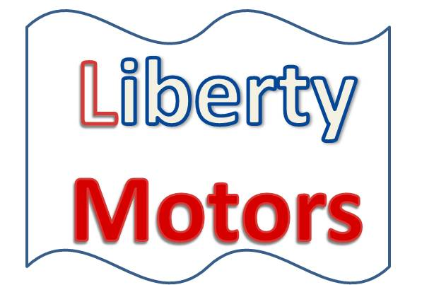

September 8, 2016

Dear :

**Liberty Motors is a proud sponsor of the annual 5K and 10K events.**

**Date:** Saturday October 15, 2016

**Time:** 8:30 AM (Race Day Registration will begin at 7:30 AM)

**Registration:** In person at Liberty Motors Showroom, on-line registration at www.libertymotors.com

**Entry fees:** $20 before 10/1/16, $25 thereafter and race day, $50 for families of three or more

**Awards:** Free T-shirts to the first 100 entries

**Course:** A slightly hilly course that starts in front of the new car showroom, and then winds through the quiet back streets of the area. The finish line will be at the entrance of the service department.

Please march with me!

Phillip Garrett